Exersice

01.

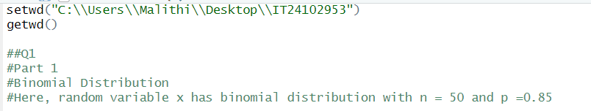

02.



